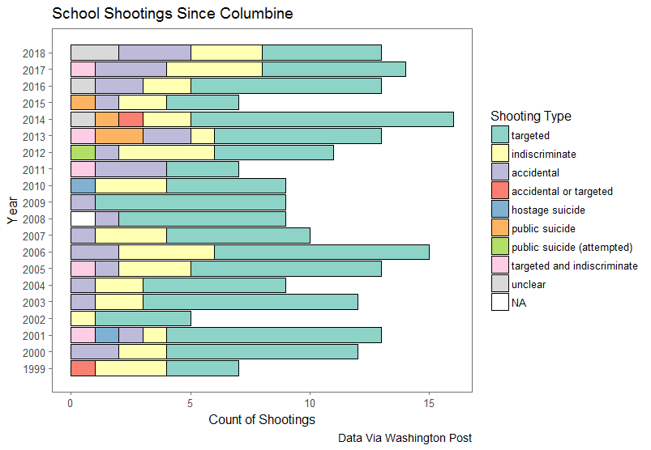Though it was not the first of its kind (see ‘I don’t like Mondays girl’), the shooting at Columbine High School in 1999 marked a watershed moment for American K-12 education. School shootings have been a persistent feature of American public education since then; such events captivate the national media and public discourse, though often only for brief periods of time (citation). Much research and public discussion has focused on theoretical causes of such incidents, with variable focuses on media and popular culture (e.g., violent video games and music), the availability of guns, bullying in schools, and adolescent mental health. Schools reacted by implementing metal detectors and increasing police presence, though this response was racially disparate (citation?). The main line of research and discourse has operated on the assumption that identifying the causes of such incidents can allow schools and policymakers to implement reduce their frequency. For example (insert section on Virginia Threat Assessment here, cf. Cornell)

Since the shooting at Columbine High School in April of 1999, the frequency of such shootings has remained roughly constant, with about 11 (plus or minus 3) such incidents per year. In fact, this year, at the time of writing of this literature review, there have already been 13 such incidents, indicating that 2018 may be an outlier year for the phenomenon. The data suggest that rather than being an *increasing* trend, as perhaps portrayed in the media,

Cohen, Azrael, & Miller 2015 think it’s increasing

https://www.cdc.gov/mmwr/preview/mmwrhtml/mm5209a1.htm

(Newman, Fox, Harding, Mehta, & Roth, 2004).

Muschert 2007 goes here too, unfortunately….)

nor a trend *reduced* by improvements in public policy and school safety measures,

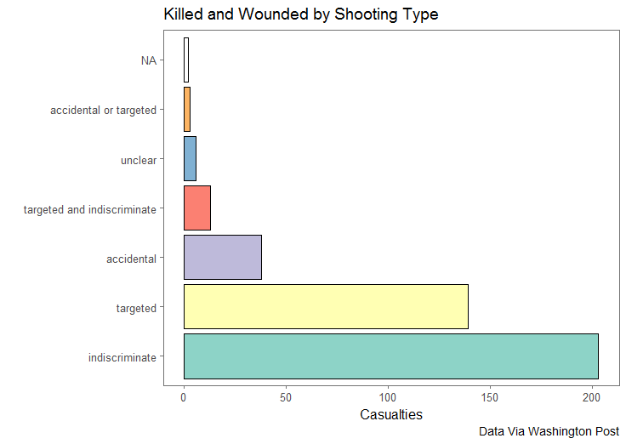The data suggest that such shootings happen at all grade levels, with elementary schools represented (e.g. Buell Elementary School in 2000, when a six-year-old targeted and killed an individual at his school with a handgun) as well as shootings in post-secondary education such as the Virginia Tech incident in April, 2007. The greatest number of these incidents are targeted killings of other individuals within the school; however, the greatest number of casualties, and the greatest cultural impact, come from indiscriminate killings with no apparent targets other than the school community itself. As such, some school shootings can be considered to be a kind of community trauma, impacting more than just those students who are physically victimized but also myriad school and community members who will experience varying levels of post-traumatic stress and psychological and mental health needs as a result of the incident. It is on these terms that this paper will review the literature: it will engage with some literature on trauma and schooling in general but will focus on incidents of mass trauma with an emphasis on violence in and around schools. How much is known about the extent of psychological trauma experienced by those who survive incidents of school violence or crisis, and what programs and policies have been studied which attempt to lessen the impact of such events? Moreover, how do school districts attempt to resume normal operations of schooling and community functioning in the wake of such incidents?

If we want to get into causes, Muschert 2007 has a good list of ridiculous proposals.

Nurmi (2011): “Collective trauma is created by a disaster that ‘damages the bonds attaching people together’ (Erikson, 1976, p. 154.) In Jokela, in addition to the people killed or injured in the shootings, the 500 students and members of staff of the school, as well as their families can also be considered victims in the sense that the events completely disrupted the course of their everyday lives. But what can be said about the victimization of the community at large?” use this to define typology at the outset.

Collective trauma v individual trauma, then turn to school shooting trauma.

|  |  |  |  |
| --- | --- | --- | --- |
| **Sections by Order** | | | |
|  | **All trauma** | **Mass trauma** | **School shootings** |
| **Prevention** | **X** | **X** | **(1) (short)** |
| **Effects** | **(2) (short)** | **(3) (longer)** | **(4) (full)** |
| **Programming** | **(5) (very short)** | **(6) (longer)** | **(7) (longest)** |



(Comer et al., 2010; Eisenberg & Silver, 2011; Gould, Munfakh, Kleinman, Lubell, & Provenzano, 2004; Hoven et al., 2004)

(Dyregrov et al., 2003)

**The Impact of Exposure**

It is well-known that exposure to violence has numerous impacts on children’s wellbeing, both for their mental health and for their functioning within schools. Students who have been exposed to violence of any kind are more likely to exhibit behavioral and emotional difficulty such as oppositional behaviors or aggression (Ayer et al., 2017) and the effects of such violence tend to be more pronounced for groups who are already at risk: Males, African Americans, high school students, lower income students, and urban students are all at a greater than average risk for exposure to violence of any kind (Bowen & Bowen, 1999) and it has been shown that low-income students, racial minorities, or those with extant emotional and behavioral difficulties (Ayer et al., 2017, Sharkey et al., 2014) are more severely impacted by exposure to violence than other groups.

For schools, the effects of exposure to violence go beyond conduct and behavior. For example, Jaycox et al (2006) note that students who have been exposed to violence have been associated with decreased IQ and reading ability (Delaney-Black et al., 2002) and lower GPAs (Hurt et al., 2002), as well as more frequent absences and decreased likelihood of graduation (Beers and DeBellis, 2002; Grogger, 1997). Students can be exposed to violence in the home, but even unrelated violence in a students’ neighborhood can decrease test scores or likelihood of passing (Sharkey et al., 2014). Exposure to violence in the form of war and civil conflict has even larger impacts on students’ access, attainment, and achievement (Burde & Linden 2013; Dabalen & Paul 2012; Shemyakina, 2011; Swee, 2015).

However, violence is not the only trauma that can impact student wellbeing; natural disasters have also been shown to impact student mental health and academic performance.

Siriwardhana, Pannala, Siribaddana, Sumathipala, & Stewart, 2013;

“Another study by Weems et al. (2013) showed no direct relationship between hurricane-exposed children and academic achievement but found an indirect relationship between PTSD and test anxiety.”

Saigh et al., 2006; Weems et al., 2013)

E.g., Pine (2015) showed through focus groups with teenagers that recovery, in particular being less fearful about disasters, benefited from research and knowledge, as well as group discussion of the natural disaster. Blanc et al. (2014) attempted to show the efficacy of a program for students after the Haitian earthquake in 2011, and in so doing found that more than 50% of their sampled students exhibited symptoms of Post-Traumatic Stress Disorder (PTSD) one year following the disaster. This figure is high, but not abnormally so: Murtonen et al. (2011) report that rates of PTSD for adolescents following traumatic experiences in general are roughly 30-40%. Ng (2014) found that students and families were generally fearful following a natural disaster, but a return to normalcy, in this case schooling, helped to reduce these fears. Prinstein et al., (1996) found similar results: PTSD-like traits were common among children and families after Hurricane Andrew, but that assistance with coping helped with some of the symptomology. Importantly, they found that more of this coping came from parents and friends than from teachers. Jaycox (2006) writes that schools are increasingly the locus of psychosocial support for children affected by trauma of any kind, including mass trauma; if Prinstein et al. were to attempt the same study two decades later, would they still find that teachers are less involved in coping assistance?

School shootings in particular are a kind of mass trauma that is the subject of more research, particularly as the phenomenon has spread. For example, despite the relative paucity of shooting events in Europe, two incidents in Scandinavia provide a large amount of data and research on the impact of shooting trauma and the efficacy of community response. Unsurprisingly, mass shootings have been found to impact students’ mental health, attention, and ultimately school achievement.

Strom (2016) details these effects in a study of students who were present at a shooting at a summer camp in Norway. These students’ grades dropped in the year following the attack but had begun to recover in the second year. Additionally, they were more likely to be absent from school following the event. Dyb et al., (2014a) interviewed the same population of victims and found that the prevalence of PTS-levels were six times higher among these adolescents than in the general population. They also found that gender, ethnic minority status, level of exposure, peritraumatic reactions, interpersonal loss, and current pain were all significantly associated with PTS symptomology for survivors of the shooting.

In two separate incidents in Finland, students targeted and killed peers before committing suicide. Nurmi (2011) used surveys and interviews to investigate community-level effects after one of these shootings. While the trauma did enhance feelings of solidarity, students reported that their experiences with community outsiders were harmed. For example, one participant indicated that she believed that fewer students would seek to go on to the next level of schooling, which would require them to go to a nearby town, as students would wish to avoid exposure to students who may inquire about their experiences with the shooting. This finding is important, as it is known that processing and discussing traumatic events can be helpful; however, it appears to be important that such processing occurs within a community rather than with outsiders. This need to avoid discussion with non-community members may underlie the finding that student victims of community trauma are more likely to miss school in the aftermath. Nurmi (2011) indicates one more crucial feature: processing with peers may hinder progress relative to discussing traumatic events with teachers and parents.

However, the effect on school attendance appears to be multifaceted; Brener et al. (2002) found that students at Columbine high school reported occasionally being too fearful to attend school in the wake of the tragedy.

Liao et al. (2015) fit a two-piece growth-curve model to student disruptive behaviors and found that there was an increase in such behaviors in the time following a school shooting in their data set. The theory contends this causal model: school violence increases the likelihood that students will experience negative emotional and behavior states, such as disruptive behaviors. These cognitions and behaviors then function to decrease student achievement. With appropriate data, it may someday be possible to fully trace this structural model to determine more precisely the ways in which violence, mental health, conduct, attendance, and achievement interact. For example…

Muschert (2007):

“Addington (2003) found that the fear of victimization reported by US students aged 12–17 did not significantly change following the 1999 Columbine shootings. Other studies revealed an increased fear of victimization among secondary school students in Texas (Snell et al. 2002) and among female university students (Stretesky and Hogan 2001).”

**What there is on impact of school shootings specifically**

(see e.g. material published in American Behavioral Scientist 2009: 9–10)

**Programs which Exist**

**Programs for trauma in general**

* Hickman et al. (2013) meta-analysis
  + 9 studies of Safe-Start Promising Approaches
  + No significant differences in any of the studies (ITT)
  + Except child cooperation and socio-emotional competence
* Murtonen (2011)
  + Therefore ‘watchful waiting’, that is, regular monitoring of possible trauma symptoms, is crucial. (see Charuvastra, 2010 for this in action)
  + Really Murtonen is more here than above.
  + Murtonen gives review on page 2-3 about programming
  + Suomaleinen is the same thing
* Cook-Cottone
* Dyregrov
* Openshaw 2011
* Strom:
  + their school start, 87.7% (N50) reported that the school had done something special to safeguard their teaching situation as a consequence of being at Utøya, and 89.5% (n51) reported that they had a school staff member to talk to if necessary. During the last year of high school, 84.2% (n32) reported that they received extra support the previous school year and 63.9% (n23) said that they were highly satisfied with the support/facilitation provided by the school the previous year. However, we did not find any significant relationship between school support and grades after the event
* Guzder 2011
* Kataoaka 2012
* Ramirez 2013

**Programs for community trauma**

* Prinstein
* Openshaw 2013
* Dyregrov 2015
* Jimerson 2005
* Spokane
* Zachariah 2012
* Bhadra 2012
* Ng 2014
* Mutch 2015
* Blanc 2015
* Shultz 2015
* Mutch 2016
* Saddiqui 2017

**Response to school shootings?**

* Charuvastra
* Crepeau-Hobson 2011
* Dishman
* Crepeau-Hobson 2012
* Dyb 2014 (early outreach)
* Paine (n.d.)
* Charuvastra, 2010

**Preparedness?**

* Graham 2006
* Weisbrot 2008 (maybe… if there’s time)
* https://nces.ed.gov/pubs2017/2017064.pdf

**(Follow the money?)**

**Media issues? (NO)**

**References**

**Ayer, L., Setodji, C., Schultz, D., Jaycox, L. H., & Kofner, A. (2017). Change in externalizing problems over time among ethnic minority youth exposed to violence. Children and Youth Services Review, 82, 19-26.**

**Delaney-Black, V., Covington, C., Ondersma, S. J., Nordstrom-Klee, B., Templin, T., Ager, J., ... & Sokol, R. J. (2002). Violence exposure, trauma, and IQ and/or reading deficits among urban children. Archives of pediatrics & adolescent medicine, 156(3), 280-285.**

Suomalainen, L., Haravuori, H., Berg, N., Kiviruusu, O., & Marttunen, M. (2011). A controlled follow-up study of adolescents exposed to a school shooting–Psychological consequences after four months. *European Psychiatry*, *26*(8), 490-497.